

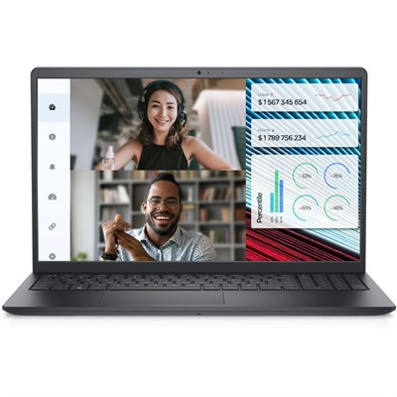

# Dell Vostro 3520 Laptop

• Intel® Core™ i3-1215U Processor 6C, Intel® UHD Graphics

• 8GB DDR4 2666MHz, 512GB M.2 PCIe NVMe SSD

• 802.11ac 1x1 WiFi, Carbon Black Color

• 15.6" FHD 120Hz 250n Narrow Border Display - Ubuntu Linux